# Products and Services

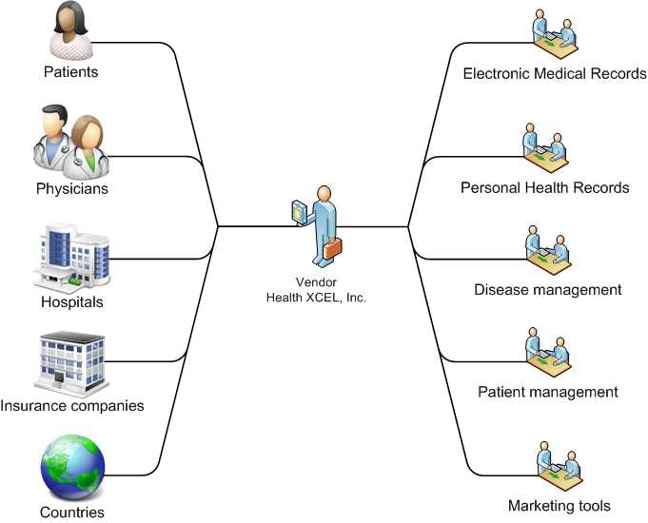

Hxcel’s flagship technology, “GlobalHealth” combines cutting edge technologies and medical standards with what we know about successful online relationship management and allows users to create quality health care applications that can securely interoperate with each other and other external applications.

GlobalHealth is:

* Platform built on accepted standards
  + Security
  + Data exchange
  + Medical
* Vertical 1-stop shop for health professionals
* Centralized system
  + Secure storage / transmission
  + Standards based
    - ICD-10, ICPC-2, HL-7
    - SSL, AES-256 (encryption)
  + SOA for integration
  + Authentication & Access Control
* Client-centric, permission-based model
  + Patient controls / manages her electronic medical records (EMRs) created by doctor
  + Patient shares the records with other doctors
  + Patient facilitates record creation by keeping Personal Health Records (PHRs)
  + Patient manages her emergency records

## Enterprise & Interoperability

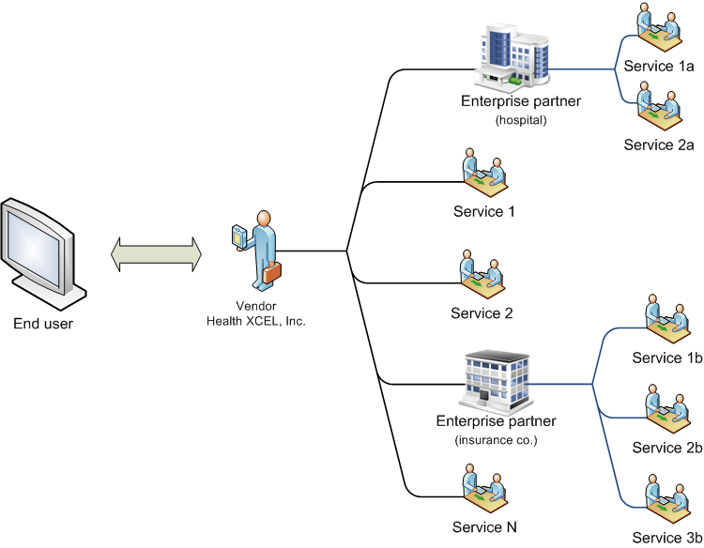

Figure . 3rd party enterprise interoperability

Globalhealth was built with the enterprise in mind. We don’t want to be another closed proprietary system. We want to be the “open framework” standard built on standards when it comes to storing and sharing Electronic Health Records online.

To make such a software platform a reality, we have chosen to leverage the Platform as a Service (PaaS) model, and by association, Software as a Service (SaaS) and optimized and fine-tuned it for the health care sector. We have affectionately termed the new model “Healthcare as a Service (HeCaaS)”. To understand HeCaaS.

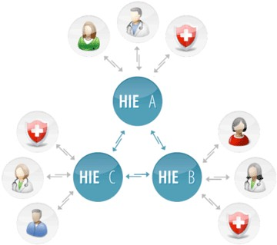

## Healthcare as a Service

The Globalhealth HIE starts with this premise of a centrally managed platform, where 3rd party vendors can install and manage their eHealth applications.

Healthcare as a Service adds its own characteristics on top of PaaS and SaaS:

* Interoperability.
* Security
* Customization

### Interoperability

*“Interoperability is a property of a product or system, whose interfaces are completely understood, to work with other products or systems, present or future, without any restricted access or implementation.”*

The Globalhealth HIE was conceived, first and foremost, because eHealth applications today need to be always-on, super redundant and ultimately infinitely scalable and, most importantly, be able to communicate with each other and understand the data they use to communicate with.

Globalhealth, applications created by different vendors and deployed onto the platform, can speak to each other over agreed upon transmission protocols and interfaces, internally to the platform and externally to other HIEs. The goal is to centralize health care records onto a few HIEs around the world, have the HIEs synchronize that data across themselves, and make them available to everyone, anywhere, without the need for anyone to install expensive systems locally. Data will be available, securely, from a laptop, smart phone or tablet computer.

### Security

Regular SaaS implementations already entertain the concepts of security and access control. HeCaaS extends this premise and adds to it a patient-centric rights approach that includes, but not limited to:

* Patient record level sharing
* Emergency record level sharing
* Provider to Provider access rights

### Platform Applications

Application vendors can create, test and deploy their applications on the platform. We foresee an exponential growth curve from vendors applying to be approved for the platform. There will be an approval process in place to ensure quality and to avoid duplication.

We will create, the most useful applications in advance. Below we have outlined, in order of importance, the core applications accompanying Globalhealth at launch.

1. Electronic Medical Records (EMR)
2. Personal Health Record (PHR)
3. Emergency Records
4. Disease Management (DM)
5. Scheduling
6. Billing
7. Relationship Management
8. Professional tools
   1. Profile
   2. Ratings
   3. Blog
   4. Forum
   5. Chat
9. Messaging and Reminders
10. Revenue making opportunities

#### emr_data_sharing.pngElectronic Health Records (EHR)

When you go to your physician for a check-up, the physician will write down all the results from that meeting in your journal. A journal can contain past illnesses, some information on illnesses in your family, lab tests such as x-rays and anything else the physician deems important to build a solid health profile about you. Depending on your physician, this can be a completely paper based journal or saved on a computer somewhere. We empower physicians around the world with the ability to create electronic journals for their patients and store all information pertaining to the patient’s health online in a centralized and secure repository. The patient can manage these journals and choose to share them with other physicians in their network.

#### Personal Health Records (PHR)

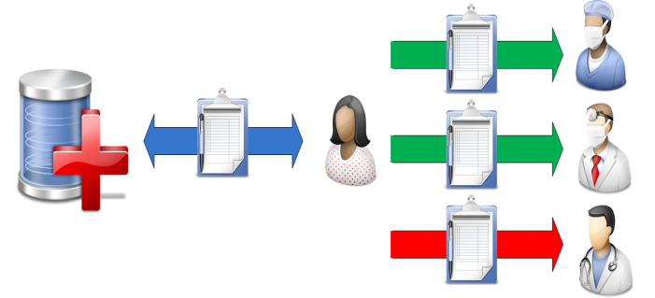A PHR is a piece of information retained by the patient who deems it relevant to save as part of the patient’s own medical history. When you go to a physician and are asked to fill out a piece of paper about your past history, that’s a simple version of a PHR in paper form. Now patients can facilitate the information gathering process usually done by their physicians by creating their own personal health records (PHRs). Information retained in a patient’s PHR is basic information the patient can fill in herself. Allergy, medication and immunization records are good examples of these. This saves health professionals time and money, as the information they usually would have to record is already available in electronic form. Patients can choose to share all or parts of this information with their health professionals.

#### **Emergency Records**

Every record the patient can manage can be marked as an emergency record. An emergency record is a ”portable” piece of information that should be accessible to anyone in the case of emergency (break-the-glass scenario). Think of it as the patient’s public profile on a community site. In the event of an accident, a physician outside the patient’s trusted network can still have access to the most important information and avoid making misdiagnoses, which could have fatal consequences. E.g. the patient could be deadly allergic to a certain drug that the physician usually prescribes for his patients in similar situations. Emergency records would help prevent these unfortunate and easily avoidable cases from occurring due to lack of information.

#### Patient management

Patient management is features that make it easier for physicians and patients to communicate.

##### Scheduling

The calendar is at the heart of how patients and physicians interact. Any meeting begins with an appointment request. A meeting can be a single or group meeting. It can be a one-time meeting or it can recur over time. Both patient and physician can request an appointment with the other. They can access each other’s calendar and see what time works for both. If the time is convenient the other person confirms the meeting and both receive reminders a few days before via phone, SMS or email. If one party needs to cancel or reschedule, the other party will be notified of the cancellation or asked to confirm the new proposed meeting time. Our calendar and scheduler is one of our most advanced features and offers a lot of flexibility for our clients. Our users also have the ability to sync their schedules with MS Outlook, Mac iCal, Chandler and other iCalendar compatible calendar applications.

##### Messaging and reminders

We have created an enterprise messaging application that can monitor, alert and connect medical personnel with patients and their loved ones. Using the latest in IVR (Interactive Voice Response) and VOIP (Voice Over IP) and text messaging technologies. These features are a subset of the larger sector called Disease management and can be used to answer phone based questionnaires, send prescription refill reminders and get in them in touch with the right people should it be necessary.

We also use it to send out reminders and confirm appointments via email or text messages to our physicians and patients.

#### Relationship management

Social networking platforms are great tools for creating stickiness, promoting communities of likeminded people and encouraging new users to sign up. We’ve taken the core of social network functionality and named it relationship management. There are 3 levels of relationship management in our system:

##### Basic

Patients and physicians can seek each other out and request a relationship with the other. Patients will usually find a physician through their profile. Physicians also have a similar way to find patients. Once the connection is made, they can begin to make appointments and share documents.

##### Enterprise

Organizations, such as health providers, can easily manage their physicians and patients through us. The difference between this type of relationship and the basic patient-physician relationship is that the “ownership” of the patient lies with the provider and not with the physician. The patient is instead assigned to the physician rather than having a direct relationship.

##### Country

Countries have the ability to manage organizations, physicians and patients within their own country. The most important features that countries want are to be able to run statistics, track spending, sicknesses, flu outbreaks etc. They want the end result of the data that gets inputted on a daily basis from physicians and patients.

#### Promotional tools

Physicians are given a set of promotional tools. Their value lies in being able to create customer stickiness, giving them an online presence and being easily found when customers search for physicians.

##### Profile

The first thing a patient will see when searching for a physician is the physician’s profile. This page is the physician’s advertising banner and we’ve given them the utmost in flexibility by letting them create their profiles through text, images, sound and video.

There is also a structured section where they can enter in all their professional information such as education, certifications, specialties, published articles etc (*page 25*). The goal is for the profile to tell a story that is compelling to the potential patient.

##### Publications

Physicians can publish articles and other written material in this section. It can help establish credibility and give the physician another creative outlet.

##### rating.pngRatings

A feature we were especially keen on offering was the ability to rate a physician. Being able to browse customer feedback for a physician you are potentially interested can help people decide if this is the right physician for them. High rated physicians will have a greater volume of patients and help drive traffic and revenue for us. It gives the physician a greater incentive to offer a higher quality of service and the potential customer a clearer overview as to what is being offered and what she can expect.

##### Blog

Every physician has an optional blog they can use to write about anything of interest that doesn’t fit into the Publications section. Their blog is easily accessible and searchable from their profile. Blogging about news and events in their knowledge domain will lead to a higher likelihood of being found by potential customers.

##### Forum

The forum adds another level of interaction with the physician. Patients and potential customers can ask questions. Answers to previous posts can determine whether they need to make an appointment to see the physician in person or not.

##### Live chat

Patients and physicians who have an existing relationship can chat with each other. This functionality puts any one of our physician’s (or their assistants) at the patients’ fingertips for those urgent questions.

## Revenue sharing: Virtual practices

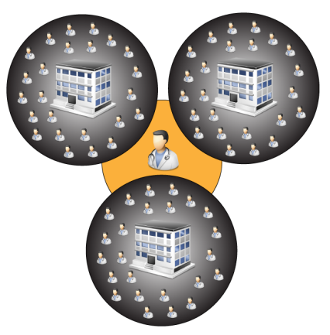This is a marketing and recruiting tool. Health professionals have the opportunity to create a “virtual practice” within our system. A virtual practice exists of a group of physicians who are paying for any of our monthly services. The owner’s goal is to recruit as many high paying physicians as possible. The reward is a percentage of the total monthly subscription fee of all the “employees”. The more members an owner can recruit, the higher the percentage rate she will receive. The goal for an owner is to recruit to the company’s maximum capacity but also to recruit the customers who pay the highest subscription fees.

The incentive for a physician to join such a company is the monthly discount she receives. She gets a greater discount based on how well the company is doing.

We’re charging a one-time fee for company owners to create a company. This price is set high so not everyone will want to create a company but not too high to deter motivated customers. A successful company owner can recoup her investment within 3 months and enjoy a steady income after that, and the new subscription fees they generate for us recoup the money we credit company owners.

----------------------------

## Professional consulting services

We offer professional services to our enterprise customers who need help with custom integration and migration procedures.

### Application creation

As described in the section below called “Enterprise & Interoperability”, enterprise users are able to deploy their applications onto Globalhealth. Many of our companies do not have the necessary resources to do this type of application development and would rather hand the work off to someone who has worked extensively with the platform.

### Migration

Migrating data is an intricate procedure and moving data from a legacy system to a new one is a bit of an art form. Enterprise users wishing to upgrade their system by putting their data onto our state-of-the-art framework can easily do so. We do all the necessary migration for them and create custom widgets for them, on an as-needed basis, to expose their data within Globalhealth.

# The Story

These stories are designed to show how both patient and physician can save valuable time and money and get an overall higher satisfaction by using Globalhealth.

## Before Globalhealth

Miss Yu is having pains in her kidney and decides to go to a physician to have it looked at. As she just switched jobs and her new job carries a different health insurance, she has to first find a new general practitioner. The insurance company has a large book from which to choose from and she picks a female physician in her area and calls to make an appointment. A few weeks later she is sitting in her new physician’s office. She completes the standard form the office assistant gives her. The form consists of general questions concerning her past and present health. The physician runs some standard tests on her and tells her the test results will be available the following week. The GP calls her up the following weeks to tell her that the test results show that she has a kidney stone and the physician recommends a specialist, Dr. K. Idney.

Miss Yu calls the specialist and makes an appointment. The specialist’s secretary calls Miss Yu a few days before to confirm the appointment and to remind her to bring her file from the GP. Miss Yu tells her GP she has to stop by and pick up a copy of her file before going to the specialist. As she enters the office of Dr. K. Idney, the office assistant asks her to fill out the same standard questionnaire about her current health. The assistant makes two copies and files one away in a file cabinet marked Y.

Dr. K. Idney invites her into his office and looks over her file. He also runs some quick tests on her and concludes that a minor operation will be necessary. He schedules an operation date and sends Miss Yu on her way. His assistant calls a few days before to confirm the operation date.

The operation is a success and Miss Yu is back on her feet a couple of days later.

## After Globalhealth

Miss Yu is having pains in her kidney and decides to go a physician to have it looked at. As she just switched jobs and her new job carries a different health insurance, she has to first find a new general practitioner. She goes to <http://globalhealth.hxcel.com> and searches for female physicians in her area that accepts her insurance. She finds one she likes based on the physicians’ online profile and patient ratings. She sees an available slot on the physician’s calendar and requests an appointment.

Miss Yu’s last GP recommended that she sign up with Globalhealth so she could see the results of her appointments with him online. Her GP also told her it would be wise to start creating her own Personal Health Record as are very helpful and save her time when visiting other physicians. Miss Yu is very concerned about her health and likes the idea of being able to manage her own records.

A few days before her appointment, our automated notification system calls Miss Yu to confirm her appointment. She accepts and goes online and gives her new GP access to her PHR records and the results of her previous appointments with her old GP. When she gets to the physician’s office they can see all her information online. She doesn’t have to fill in a paper based questionnaire and the physician only needs to run one specific test. The physician tells her the test results will be available online within 24 hours.

Globalhealth notifies Miss Yu that the test results are available. The test shows she has a kidney stone and the physician recommends the specialist, Dr. K. Idney. Miss Yu requests an appointment with Dr. K. Idney the same way she did with her new GP. She also shares her previous records, her PHR and the new test results with Dr. K. Idney. Dr. K. Idney responds that he has all the information he needs and immediately changes the appointment to be an operation. Our notification system informs Miss Yu that the specialist is ready to perform the operation and calls to confirm her appointment a few days beforehand. Miss Yu accepts and takes a few days off work.

The operation is a success and Miss Yu is back on her feet a couple of days later.

### Story outlines the following features

|  |  |  |
| --- | --- | --- |
| **Feature** | **Example** | **Value** |
| Online physician-patient relationships | *Miss Yu’s previous GP EHR records were available to her online* | Access old EHR records from past physicians. Learn about what the physician is doing currently through her blog and forum. Ask a question. Physician-Patient relationships have never been closer. |
| EHR based records | *Miss Yu’s previous GP, her new GP and the kidney specialist all made use of EHR records for her online journal* | Standardized diagnoses and record keeping. Misdiagnoses, based on lack of information, are severely reduced. |
| Searchable physicians by gender, insurance type, physician’s own profile text and her ratings | *Miss Yu needed to find a new GP* | Overall higher patient satisfaction and better service by giving the patient greater control of who she chooses. |
| Physician online calendar where patient can schedule/request an appointment | *Miss Yu scheduled 2 appointments with 2 different physicians* | Scheduling is no longer limited to physician’s office hours. Patient can request appointments 24/7 from anywhere in the world. Office assistant has an easy interface with which to manage appointments. Both parties can sync calendar with mobile phone or PDA and any other iCalendar compatible device. Leads to greater efficiency and higher satisfaction rates for both parties. |
| Notification system that alerts all parties to changes / confirmations / cancellations of an event (e.g. appointment) via email, automated phone and text messages | *Both the physicians and Miss Yu were notified of the appointment requests and both had to approve and confirm the appointment* | With information at your fingertips you will never forget another appointment. Both the physician and the patient will always be informed about events pertaining to their accounts. |
| PHR records that allow Miss Yu to manage allergies, medical conditions etc | *Miss Yu had already compiled a list of information pertaining to her own health* | Save time and money by allowing the patient to manage records she can easily track herself. |
| Shareable PHR and EHR records that are managed by the patient | *Miss Yu could share her own EHR and PHR records with her new physicians* | Patient medical journals are no longer contained and are available, online, 24/7 to anyone with the proper credentials. |

#### Online physician-patient relationships

Patients can request a relationship with any physician they find through our network. If the physician is not yet part of our network, the patient can invite the physician to join by the click of a button. Physicians can also initiate patient relationships and can invite patients who have not yet joined our network as well.

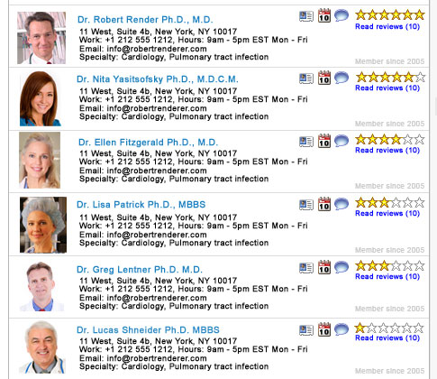

Figure My physicians

#### EHR based records

Physicians keep electronic journals for their patients. The journal allows them to keep an accurate account of patient visits over time. The journal is managed by the physician but owned by the patient.

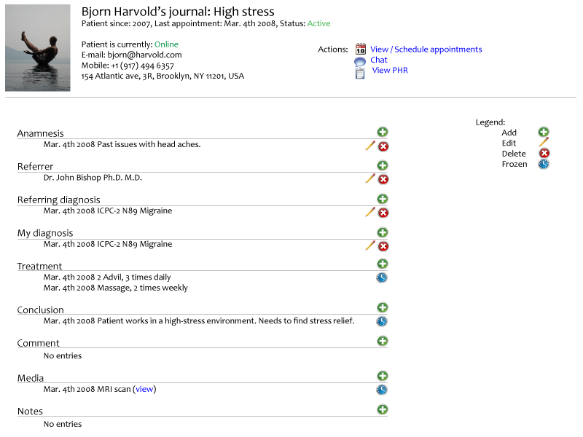

#### Searchable physicians by gender, insurance type, physician’s own profile text and her ratings

Physicians will be able to fill out a professional profile and their own “marketing profile”. A professional profile consists of a structured list recounting their career. A marketing profile is text that is meant to sell them to their prospective clients. This includes introduction text, blog entries, forum posts and other media such as images, video clips and audio that showcases who they are professionally and portray their character.

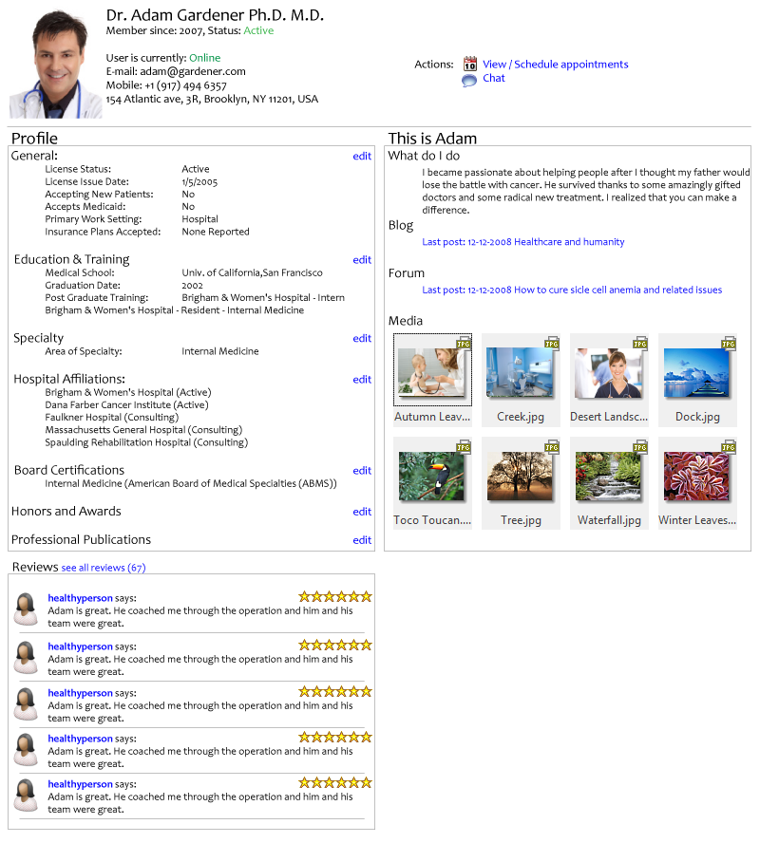

#### Physician online calendar where patient can schedule/request an appointment

Once a relationship has been established the patient and the physician can begin managing appointments with one another. There are always two views to a calendar, the owner view and the guest view. The guest viewer, usually the patient, only sees available and unavailable time. The owner will see a detailed view of the calendar.

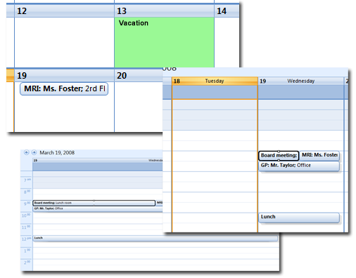

Figure . Physician calendar

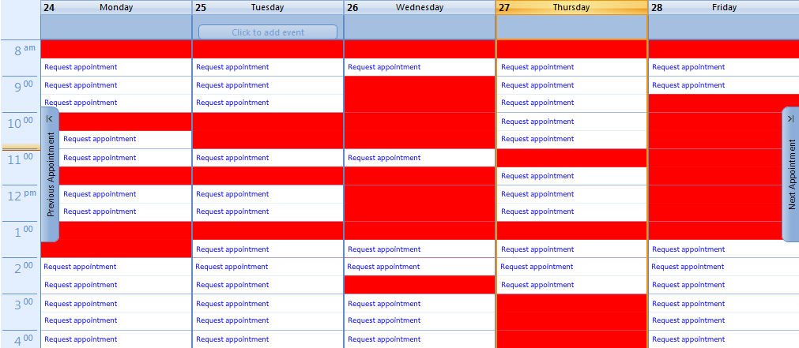

Figure . Patient viewing physician calendar

#### Notification system that alerts all parties to changes / confirmations / cancellations of an event (e.g. appointment) via email, automated phone and text messages

Our notification system makes use of email, text messaging and IVR to make sure you are always in the know about entries on your calendar. We use VOIP (Voice Over IP) to schedule conference calls, assist in connecting families with their loved ones during times of emergency and to send EMT personnel to where they are needed with a click of a button.

#### PHR records that allow Miss Yu to manage allergies, medical conditions etc

Miss Yu can create a wide variety PHR records for herself ranging from allergies, medical conditions to immunizations and eye exams. Paper-based records and x-ray results can be scanned, uploaded and associated with the PHR. The more details Miss Yu can add to her records the more valuable that information will be to her physicians and the less time physicians will spend collecting her past medical data.

